Deep Copy and Shallow Copy

Explain Deep copy and shallow copy

Deep Copy = Is performed when performed on an object that copies the underlying data of another object, the pointer as a result from the copy are different, and each point to their own copy of the data.

Show diagram deep copy.

Shallow Copy = copy only the pointer of the object and the result of shallow copy is that the pointer is still pointing to the same memory and data.

Show diagram shallow copy

Source: Lecture 13 slides 19 onwards

Desired approach = Deep Copy as will ensure 2 or more object do not have the same pointer to the same piece of memory, therefore same piece of memory will not be de allocated twice. As an error will occur if the same memory is deallocated twice.

Why is our STL data structure vector the best choice?

It is chosen because it is the closest structure that is to a vector with the necessary methods that will make the vector minimal and complete.

What is minimal and what is complete?

It has push_back that is like our Add method

It has pop_back that is like our remove method

Which method essential, add,remove,empty

Non-essential method, no need operator [ ] .

Duplicate functionality, At() and overloaded [ ]

Vector template:

<https://codereview.stackexchange.com/questions/29331/template-vector-class>

<https://stackoverflow.com/questions/25467801/trying-to-create-copy-function-in-a-vector-class>

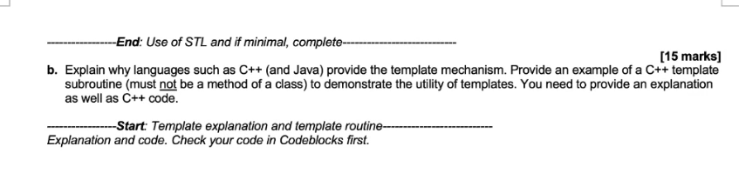f

the purpose of template is to allow the reuse of code for different data types, it is meant to be reuse.

Once the template is written, different data types are passed in.

Reason of its usage is for its reusability.

Subroutine, demo Merge as subroutine

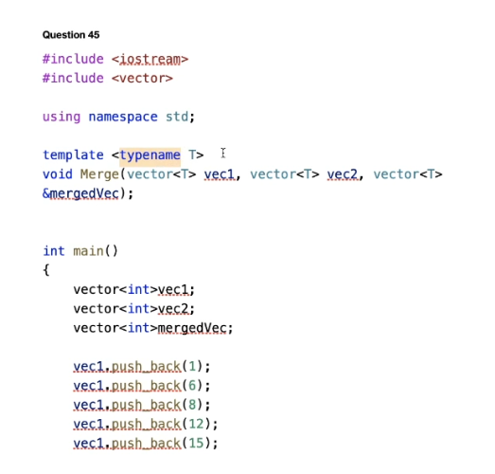

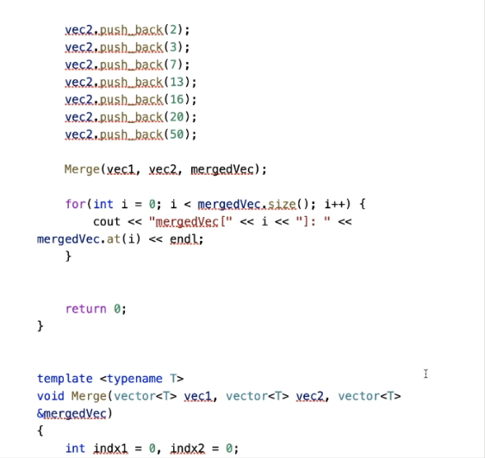

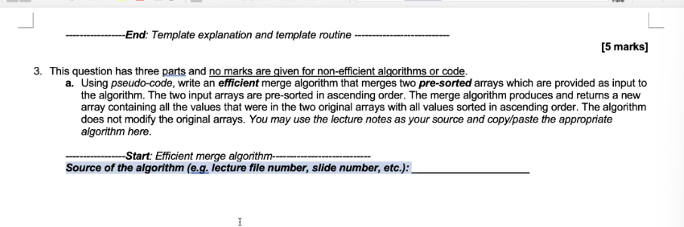

Get pseudo code and algo from slides

Lect 19 slides

Assumptions for intersection to work, both sets must be sorted, set 1 and set 2 must have unique elements.

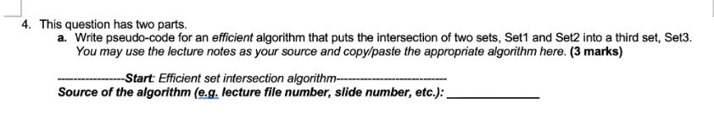

<https://www.geeksforgeeks.org/implementing-sets-without-c-stl-containers/>

https://thecodingsimplified.com/union-of-two-sorted-arrays/

Union/Intersection/Minus done in vectorTest.CPP

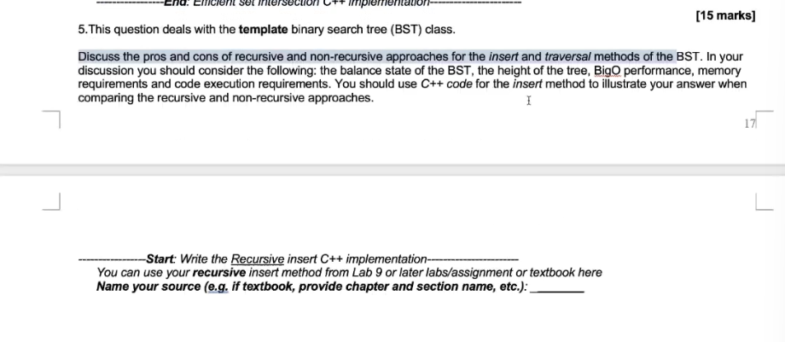

**Iterative insert working in, RAW CODE ASSIGNMENT 2 BST TEMPLATE**

In general, Recursive is easier to code, iterative more complicated to code

Memory usage wise, iterative is better than recursive, uses less memory.  
as recursive keep calling the function and use more memory every call to save the state.

**Balance state of BST:**  
BST will be unbalanded/lopsided if the data is presorted, all the node will be form on 1 side and become a linked list.

A unsorted data would be more balanced

Balance not affected by recursive or iterative

**Height of tree:**

Balanced tree has short height

Height = n

the taller the tree, the more memory recursive insert will use.

Every call saves the method in the stack

Iterative will use constant memory, only for current node, left node, right node

**BigO performace:**

Best case is: log n regardless recursive or iterative if tree is balanced

Worst case is: O(n) <<< linked list, imbalance tree, pre sorted

Overall is still o(n)

**Memory Requirements:**

Recursive use more memory, need to save the state of the of every node it visits.

Iterative use lesser memory, only need memory for current node and new node

Not as important if tree is balanced, height of tree is short.  
but recursive still use more memory even in this case.

**Code Execution:**  
iteration better in speed and memory

For readability, recursion is better.

Vid timer: 1 hr 14min ( LAST LESSON VID)

High level UML:

Only need show class and relationship, don’t need show method  
  
Low Level UML:

Need show all the method

Composition connector: if regist class is gone, result class should not exist too, therefore result is a composite of regist, it is part of regist and not standalone. Date is composite of result class

Aggregation connector: unit is aggregation of result class, unit will exist without result.

Question about template, with answer

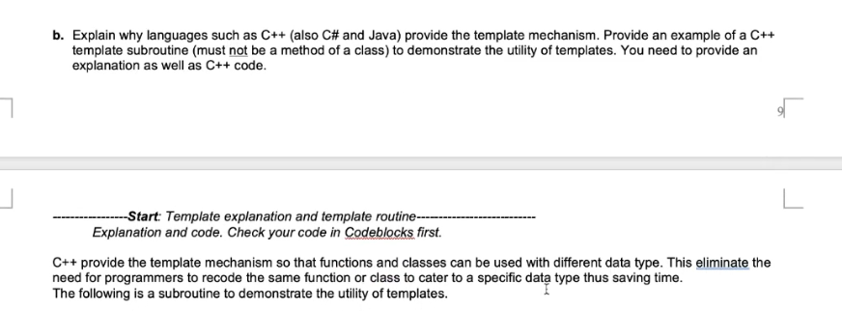

**How to make our vector template more efficient?**

For duplicate data, create pointers pointing to the save value to save memory

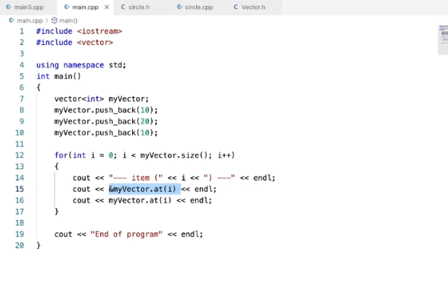

Vid timer 1hr 36min